FUNCTIONAL REQUIREMENTS DOCUMENT

30 may 2025

LEARning management system FOR SYS college

**zohaib waqar**

ex dev & Technical business analyst

Table of Contents

**Author Change Control & Approvers2**

**Introduction2**

**Glossary3**

**Functional Requirements3**

User Management3

Course Management3

Student Enrollment & Scheduling4

Content Delivery & Interaction4

Assignment & Grading Workflow4

Dashboards & Analytics5

Compliance & Reporting5

**User Roles & Permissions6**

**UI Behavior and Validation Rules6**

User Management (Register/Login)6

Course Management7

Enrollment & Scheduling7

Content Delivery & Access7

Assignment & Assessment8

Analytics & Reporting8

**Business Rules8**

**Non-Functional Requirements9**

**Assumptions and Dependencies9**

**Appendices10**

1. **Author Change Control & Approvers**

|  |  |  |  |  |
| --- | --- | --- | --- | --- |
| # | version | Date | Author | description |
| 1 | 1.0 | 30 May 2025 | Zohaib Waqar | Initial Draft |

**Reviewed By:** [Reviewer Name Here]

**Approved By:** [Approver Name Here]

1. **Introduction**
   1. **Purpose**

The purpose of this document is to define the functional requirements of the Learning Management System (LMS) being developed for Sys College. This system is intended to support the institution's strategic goal of improving teaching effectiveness, enhancing the student learning experience, and streamlining academic operations. The FRD translates business needs into detailed functional specifications that will guide the design, development, and testing of the LMS.

This document serves as a foundation for alignment among business stakeholders, the development team, QA, and implementation teams. It ensures all functional expectations are clearly defined, traceable, and testable.

* 1. **Scope**

The LMS will serve as a centralized digital platform to manage and deliver academic content, facilitate communication between students and faculty, automate grading and feedback workflows, and provide data-driven insights to department heads and executives.

The system will provide secure access for various user roles including students, faculty, administrative staff, and department heads, as well as integrations with external systems such as the Student Information System (SIS), Active Directory (for authentication), and Turnitin (for plagiarism detection). The LMS will support core academic activities such as course creation, content management, assignment submissions, performance tracking, and reporting.

This document outlines the functionality required in the initial release. Non-functional aspects such as performance, scalability, and security are addressed at a high level but may be expanded in supporting documents.

1. **Glossary**

|  |  |  |
| --- | --- | --- |
| # | Term | definition |
| 1 | LMS | Learning Management System |
| 2 | SIS | Student Information System |
| 3 | RBAC | Role-Based Access Control |
| 4 | SSO | Single Sign-On |
| 5 | KPI | Key Performance Indicators |

1. **Functional Requirements**

The functional requirements for the Learning Management System (LMS) at Sys College are derived from stakeholder interviews and business goals identified in the Business Requirements Document (BRD). These requirements define how the system should behave in support of core academic and administrative processes. The LMS will support the following high-level functional capabilities:

* 1. **User Management**

Secure registration, login, and role-based access control for students, faculty, admin staff, and department heads, leveraging integration with Active Directory for authentication.

**Description:** Handles user registration, login, authentication, and role-based access.

|  |  |
| --- | --- |
| Requirement ID | Requirement Description |
| UM-01 | The system shall allow users to register based on role (Student, Faculty, Admin, Dept Head). |
| UM-02 | The system shall authenticate users via Single Sign-On using Active Directory. |
| UM-03 | The system shall enforce Role-Based Access Control (RBAC) to limit access by user type. |
| UM-04 | The system shall provide a “***Forgot Password***” feature integrated with institutional email. |

* 1. **Course Management**

Faculty can create, update, and manage course structures, including uploading and organizing digital learning materials.

**Description:** Enables faculty to create, configure, and manage courses.

|  |  |
| --- | --- |
| Requirement ID | Requirement Description |
| CM-01 | The system shall allow faculty to create new courses with title, description, and schedule. |
| CM-02 | The system shall enable faculty to upload, organize, and update course content. |
| CM-03 | The system shall support version control for content updates. |
| CM-04 | The system shall allow faculty to archive or delete obsolete courses. |

* 1. **Student Enrollment & Scheduling**

Admin staff will enroll students into courses and manage academic schedules, with data synchronization from the Student Information System (SIS).

**Description:** Allows admin staff to enroll students and manage academic schedules.

|  |  |
| --- | --- |
| Requirement ID | Requirement Description |
| ES-01 | The system shall allow admin staff to enroll students manually or via SIS sync. |
| ES-02 | The system shall import course rosters and schedules from the SIS. |
| ES-03 | The system shall enable admin to assign faculty to courses. |
| ES-04 | The system shall provide calendar-based schedule views for each user type. |

* 1. **Content Delivery & Interaction**

Students will be able to view assigned courses, access content, participate in discussions, and receive real-time notifications.

**Description:** Supports content access, learning activity, and communication for students.

|  |  |
| --- | --- |
| Requirement ID | Requirement Description |
| CD-01 | The system shall display a dashboard of enrolled courses to each student. |
| CD-02 | The system shall allow students to view/download course content. |
| CD-03 | The system shall allow students to receive notifications on assignments and updates. |
| CD-04 | The system shall support responsive design for mobile and tablet access. |

* 1. **Assignment & Grading Workflow**

Faculty can create and manage assignments, while students can submit work through the LMS. Faculty can grade submissions, provide feedback, and use Turnitin integration for plagiarism detection.

**Description:** Manages submission, grading, feedback, and plagiarism checking.

|  |  |
| --- | --- |
| Requirement ID | Requirement Description |
| AA-01 | The system shall allow faculty to create, edit, and assign coursework or assessments. |
| AA-02 | The system shall allow students to submit assignments through the portal. |
| AA-03 | The system shall integrate with Turnitin to check plagiarism on submitted work. |
| AA-04 | The system shall allow faculty to provide grades and written feedback. |

* 1. **Dashboards & Analytics**

Department heads and executives can view performance dashboards showing trends in student engagement, course outcomes, and faculty activity.

**Description:** Provides dashboards and data insights to faculty, admin, and executives.

|  |  |
| --- | --- |
| Requirement ID | Requirement Description |
| AR-01 | The system shall display dashboards showing student performance and attendance. |
| AR-02 | The system shall allow department heads to view aggregated academic data. |
| AR-03 | The system shall generate reports on course progress, grading distribution, and compliance. |
| AR-04 | The system shall export reports in PDF and Excel formats. |

* 1. **Compliance & Reporting**

Admin staff can monitor attendance, submission compliance, and generate reports to support accreditation and internal audits.

Each of these capabilities will be further detailed in the following sections of this document, including use case flows, input/output definitions, and business rules.

**Description:** Provides Reporting tools with export feature to faculty, admin, and executives.

|  |  |
| --- | --- |
| Requirement ID | Requirement Description |
| CR-01 | The system shall generate reports on course progress, grading distribution, and compliance. |
| CR-02 | The system shall export reports in PDF and Excel formats. |

1. **User Roles & Permissions**

|  |  |
| --- | --- |
| user Roles | Permissions |
| Admin Staff | * Enroll students into courses * Create and manage course schedules * Monitor compliance reports * Manage user accounts for students/faculty |
| Faculty | * Create and manage courses * Upload and organize learning materials * Assign, grade, and provide feedback on assessments * View student progress within their own courses |
| Student | * Register and login to the system * View enrolled courses * Access course content * Submit assignments * View grades and feedback |
| Department Head | * Access dashboards with department-wide data * Analyze academic performance * Monitor faculty activity and student trends |
| External Systems | * **Active Directory:** Handle authentication * **SIS:** Sync student enrollment and course data * **Turnitin:** Process assignment plagiarism checks |

Each user role will see a tailored dashboard with only the modules and actions relevant to their responsibilities, enforcing **Role-Based Access Control (RBAC)** throughout the platform.

1. **UI Behavior and Validation Rules**
   1. **Overview**

This section outlines the key user interface behaviors and validation logic that must be enforced across all functional modules.

* 1. **User Management (Register/Login)**
     1. **UI Behavior**
        1. Responsive forms with role selection dropdown
        2. Input masking for password fields
        3. Success/error feedback after submission
     2. **Validation Rules**
        1. Email format check
        2. Password must meet security policy
        3. Role must be selected
        4. Temporary lockout after 5 incorrect login attempts
  2. **Course Management**
     1. **UI Behavior**
        1. Drag-and-drop content upload
        2. Version history for updated content
        3. Rich text editor for course descriptions
     2. **Validation Rules**
        1. Course title cannot be empty
        2. Schedule dates must be in the future
        3. File size/type restrictions on uploads
  3. **Enrollment & Scheduling**
     1. **UI Behavior**
        1. Calendar-based scheduling with conflict detection
        2. Auto-fill student details from SIS during enrollment
        3. Batch enrollment interface for bulk actions
     2. **Validation Rules**
        1. No duplicate enrollments allowed
        2. Courses cannot overlap in schedule for a student
        3. Only valid academic term values accepted
  4. **Content Delivery & Access**
     1. **UI Behavior**
        1. Students see progress bar per module
        2. Faculty can preview content as a student
        3. Search bar for locating specific resources
     2. **Validation Rules**
        1. Only enrolled students can view content
        2. Links or embedded videos must be HTTPS
        3. Downloads require confirmation to avoid accidental triggers
  5. **Assignment & Assessment**
     1. **UI Behavior**
        1. Submission history with timestamps
        2. Faculty can bulk-download all submissions
        3. Grading UI supports inline comments
     2. **Validation Rules**
        1. Due date must be in the future
        2. Students cannot resubmit after due date
        3. Grade input must match grading scale
  6. **Analytics & Reporting**
     1. **UI Behavior**
        1. Role-based dashboards (customized KPIs)
        2. Filter options (by course, student group, term)
        3. Export buttons for PDF/Excel
     2. **Validation Rules**
        1. Only authorized roles can view dashboards
        2. Filters must be applied before export
        3. Data access adheres to privacy roles

1. **Business Rules**

Business rules define the operational constraints and logic that must be enforced consistently across the LMS.

|  |  |
| --- | --- |
| Rule ID | Business Rule Description |
| BR-01 | Only faculty can create or modify courses they own. |
| BR-02 | A student must be officially enrolled (via SIS or Admin) to access a course. |
| BR-03 | Assignment submissions are final after the due date unless resubmission is explicitly enabled. |
| BR-04 | Department Heads can only view data for their own departments. |
| BR-05 | Authentication and access control are handled via Active Directory and RBAC (Role-Based Access Control). |
| BR-06 | Each user must have only one active role per login session. |
| BR-07 | All assignment files are stored with timestamps and version control. |
| BR-08 | Grading scale is fixed (e.g., 0–100) and cannot be modified without admin privileges. |
| BR-09 | Plagiarism checks are automatically triggered upon student submission. |

1. **Non-Functional Requirements**

|  |  |
| --- | --- |
| Category | Requirement |
| Performance | The LMS must support at least 1,000 concurrent users without degradation. |
| Scalability | The system should scale to accommodate future campuses and additional faculties. |
| Availability | System uptime must be 99.5% or higher during academic terms. |
| Security | All data must be encrypted in transit (HTTPS) and at rest. SSO via Active Directory with MFA is required. |
| Accessibility | The system must meet WCAG 2.1 AA standards for students with disabilities. |
| Usability | Key tasks (e.g., course access, assignment submission) should be completed in ≤ 3 clicks. |
| Localization | Interface must support English, with future ability to add regional languages. |
| Backup & Recovery | Daily backups are required with 7-day retention and a recovery time objective (RTO) of ≤ 4 hours. |

1. **Assumptions and Dependencies**
   1. **Assumptions**
      1. All users (students, faculty, admin) have basic digital literacy
      2. Internet connectivity is available on all campuses
      3. Integration endpoints (APIs) for SIS, AD, and Turnitin are available and stable
   2. **Dependencies**
      1. SIS must provide timely enrollment data for student-course mapping
      2. Active Directory must be configured to support SSO and MFA before go-live
      3. Turnitin licensing and API credentials must be obtained before integration
      4. Device/browser compatibility testing will be completed before launch
2. **Appendices**
   1. [Requirements Elicitation Document (dated: 03 May 2025)](https://github.com/ZohaibWaqarMalik/Technical-Business-Analyst-Projects/blob/main/02%20-%20LMS-SysCollege/01%20-%20Requirements%20Elicitation/01%20-%20Requirement%20Elicitation.pdf)
   2. [Stakeholder Interview Summaries (dated: 05 May 2025)](https://github.com/ZohaibWaqarMalik/Technical-Business-Analyst-Projects/blob/main/02%20-%20LMS-SysCollege/01%20-%20Requirements%20Elicitation/02%20-%20Requirements%20Elicitation%20-%20Questionaries.pdf)
   3. Appendix A: System Context Diagram
   4. Appendix B: MoSCoW Prioritization Matrix
   5. Appendix C: Use Case Diagram
   6. Appendix D: Business Process Flow

**Appendix A**

**WIREFRAME: USER REGISTRATION**

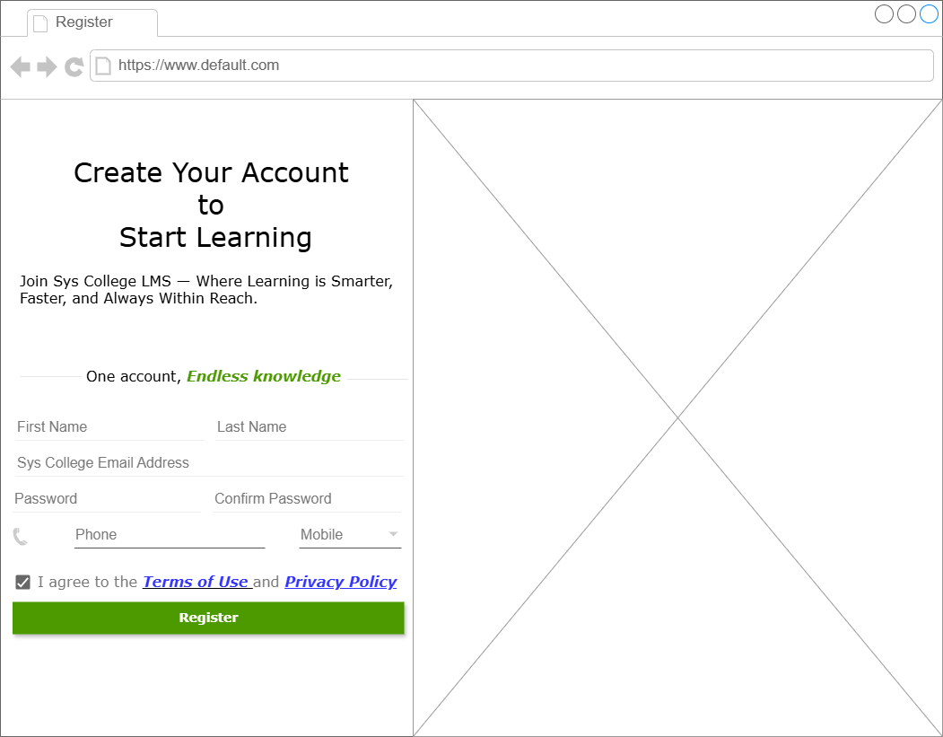

Fig A1: Wireframe User Registration

In the context diagram, the central system is represented as a single unit, with surrounding external entities connected via labeled data flows. These data flows indicate the main interactions, such as user requests, data submissions, or third-party API calls.

**Appendix B**

**WIREFRAME: USER LOGIN**

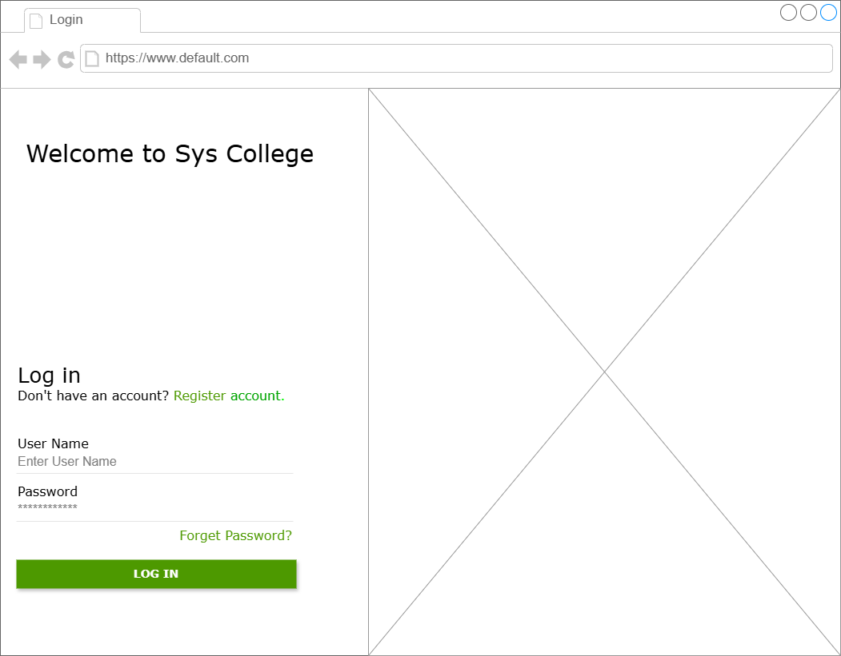

Fig B1: Wireframe User Login

This matrix categorizes business requirements using the MoSCoW method (Must Have, Should Have, Could Have, and Won’t Have) to clearly indicate priority and aid in project scope management.

**Appendix C**

**WIREFRAME: COURSE MANAGEMENT**

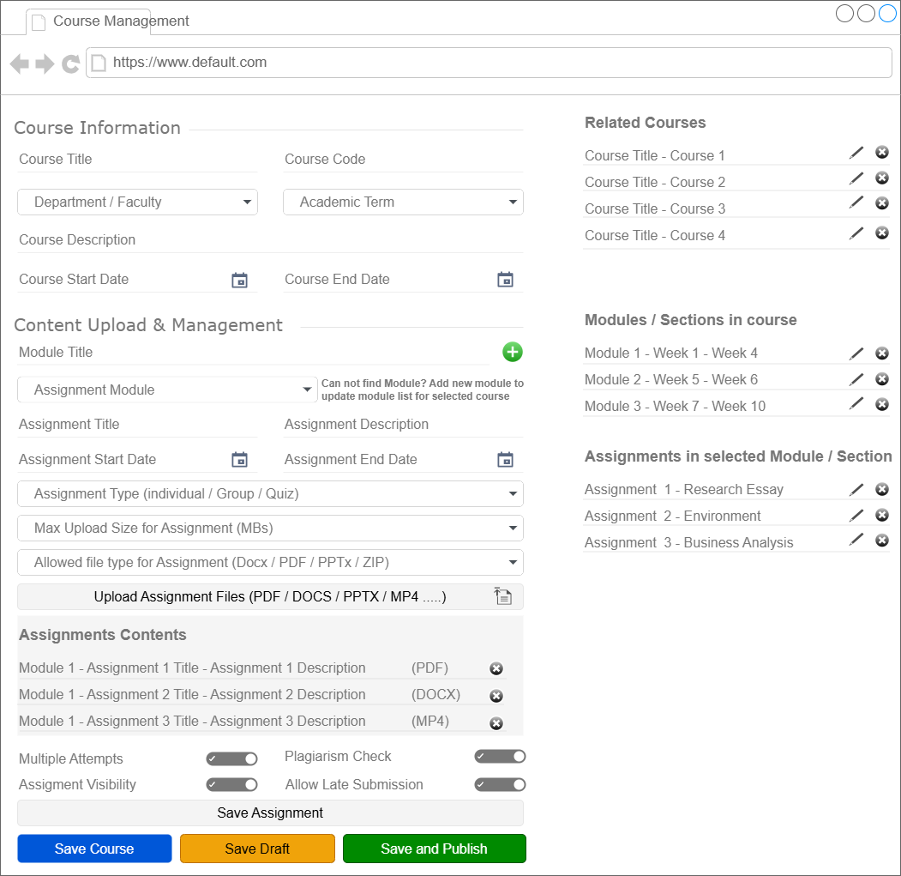

Fig C1: Wireframe Course Management

This diagram visualizes the sequential interaction of faculty, admin staff, students and dept heads within the LMS, including integration points with external services such as SIS, Turnitin, and Active Directory.

**Appendix D**

**WIREFRAME: STUDENT ENROLLMENT**

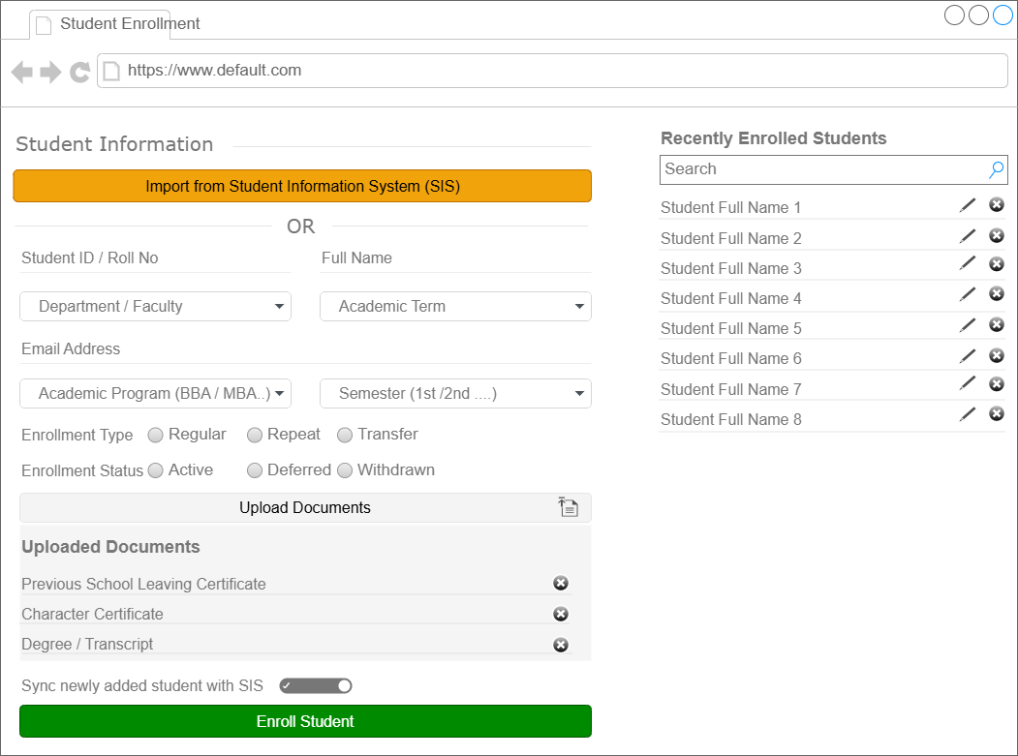

Fig D1: Wireframe Student Enrollment

This diagram visualizes the sequential interaction of faculty, admin staff, students and dept heads within the LMS, including integration points with external services such as SIS, Turnitin, and Active Directory.

**Appendix E**

**WIREFRAME: COURSE SCHEDULE**

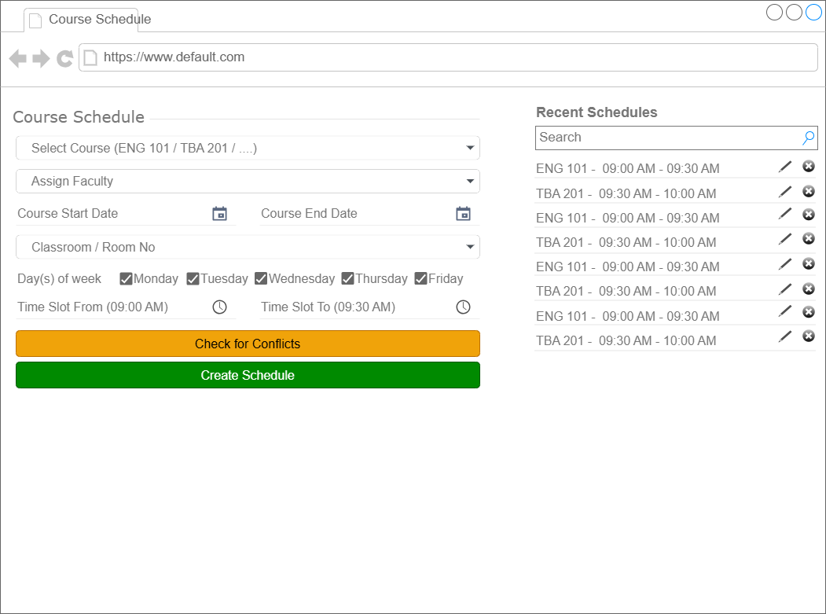

Fig E1: Wireframe Student Enrollment

This diagram visualizes the sequential interaction of faculty, admin staff, students and dept heads within the LMS, including integration points with external services such as SIS, Turnitin, and Active Directory.

**Appendix F**

**WIREFRAME: CONTENT DELIVERY AND INTEGRATION**

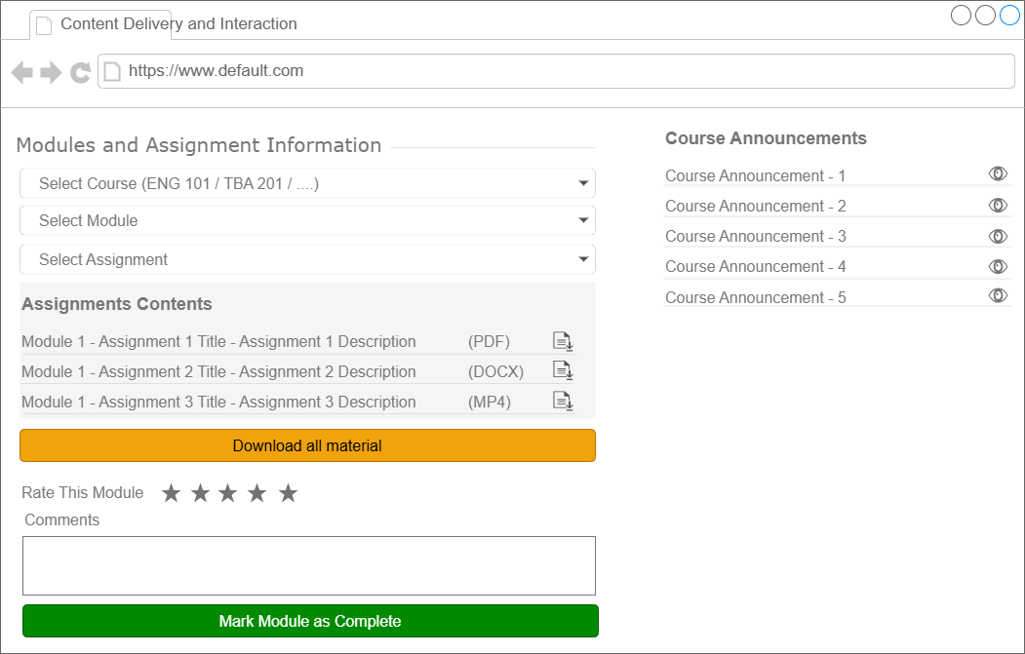

Fig F1: Wireframe Student Enrollment

This diagram visualizes the sequential interaction of faculty, admin staff, students and dept heads within the LMS, including integration points with external services such as SIS, Turnitin, and Active Directory.

**Appendix G**

**WIREFRAME: ASSIGNMENT AND GRADING FLOW**

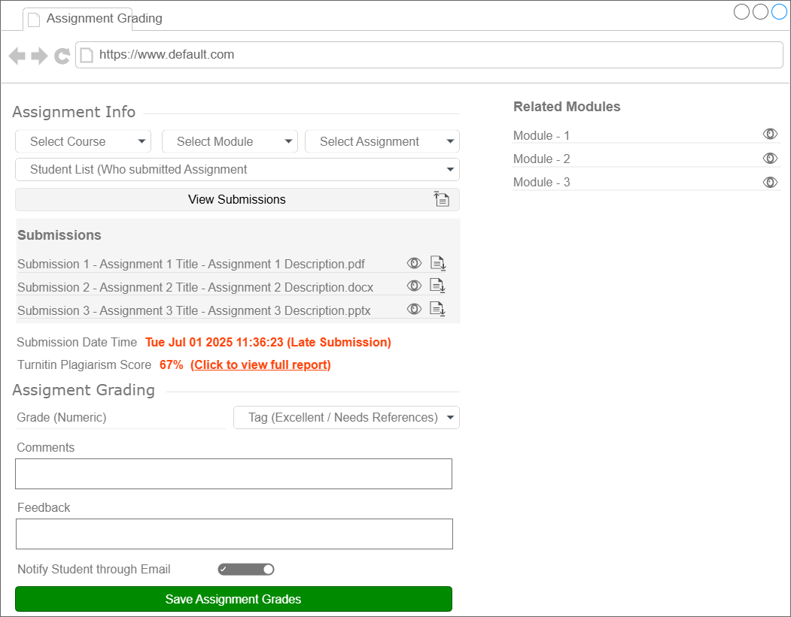

Fig D1: Wireframe Student Enrollment

**Appendix H**

**WIREFRAME: DASHBOARD AND ANALYTICS**

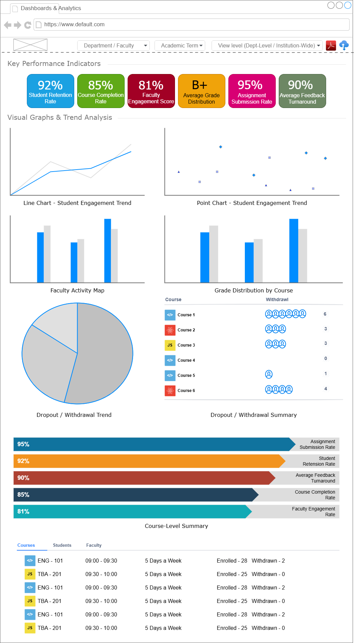

Fig D1: Wireframe Student Enrollment

**Appendix I**

**WIREFRAME: COMPLIANCE AND REPORTING**

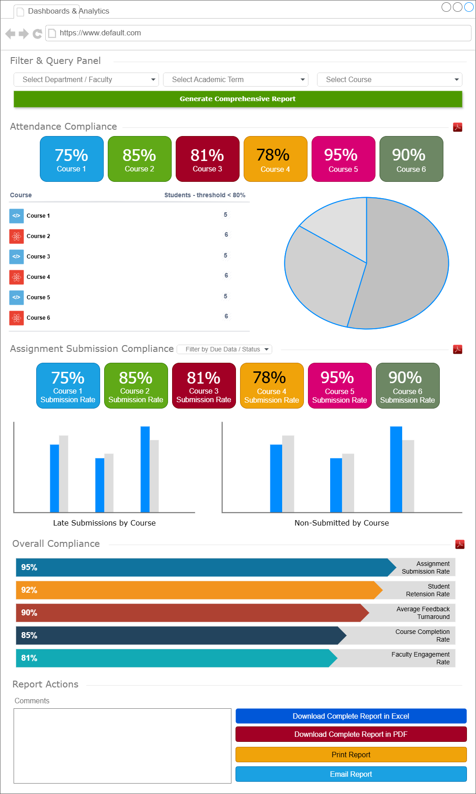

Fig D1: Wireframe Student Enrollment